Project Information
DA Assignment- 2

Team ID: LTVIP2026TMIDS37333
Team Size: 5
Team Leader: Buela Sindhu Thirumalasetty
Team member: Amaraadi Aswini
Team member: Rayudu Surya Sri
Team member: Kontham Harita Ganilakshmi
Team member: Ganja Aparna

ID: 226K1A4248
INSTITUTION: Ideal Institute of Technology
Project Title: Measuring the Pulse of Prosperity: An Index of Economic Freedom Analysis

Visualization Screenshots

- Donut Chart – Branch-wise Sales Contribution
Caption: this is made by me as gif type…
This donut chart displays the total sales contribution from each branch (A, B, C). The center highlights the overall sales volume while the segments show the proportional share by branch.
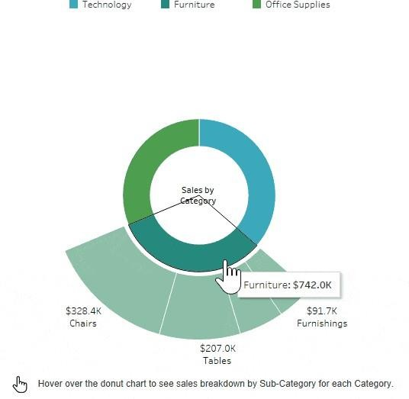

Area Chart – Monthly Sales Trend Caption:
This area chart visualizes the total sales over the three months (January to March 2019). It uses color

shading to show branch-level contributi
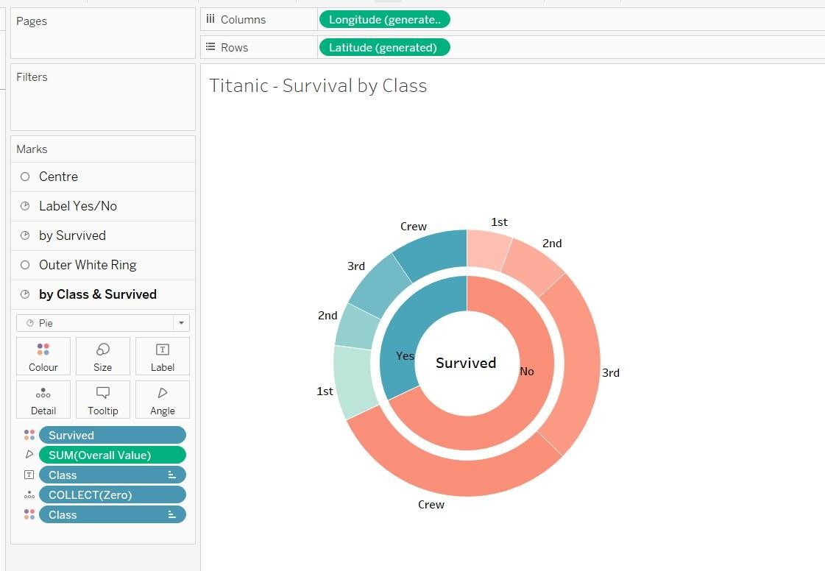on across time.

Text Table – Product Line Sales Summary Caption: converted into gif by me…

This text table provides a detailed breakdown of sales, quantity sold, gross income, and average customer rating per product line and customer type.

.

Word Cloud – Most Purchased Product Lines
Caption:
This word cloud illustrates the popularity of different product lines based on the number of items purchased. Font size reflects quantity sold.
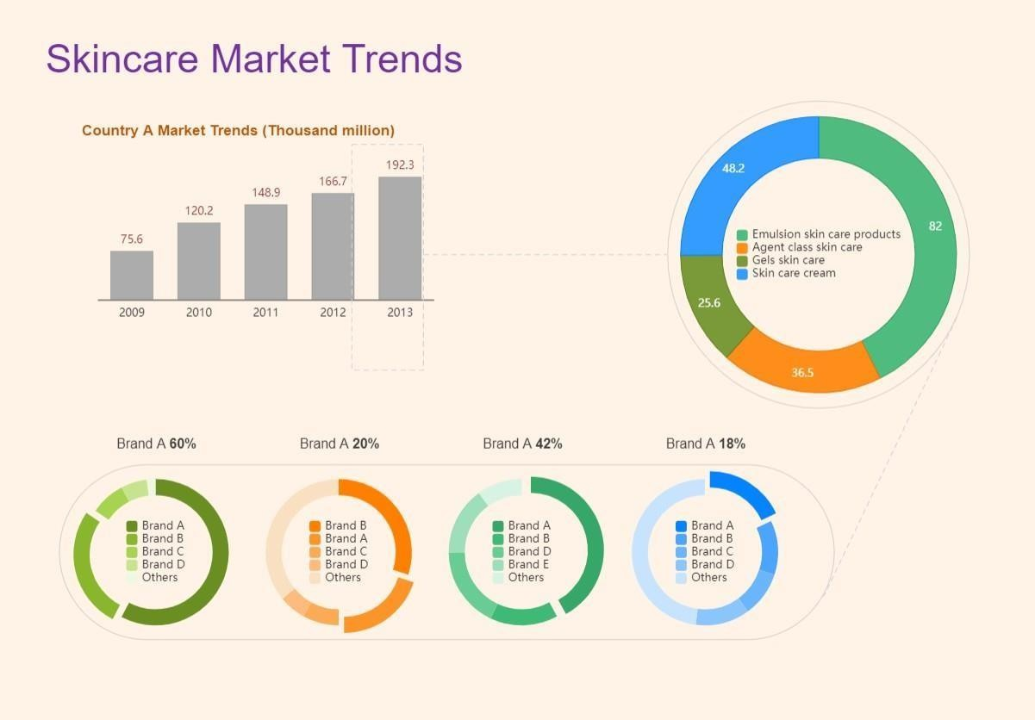
Funnel Chart – Payment Method Usage Caption:
This funnel chart visualizes the volume of sales through each payment method. It narrows from the most to least used method.

